EE-5350

Program#4

Submitted by

Burhan Ayub Wani

1001050444

Matlab code for Main

Nx=100;

C=0.01;

N1=3;

Nh=300;

Ne=100;

for n =0:Nx

x(n+1)=cos(C\*(n+1)^2);%given definition of x(n)

if mod(n,3)==0% if n is a multiple of 3, then xx(n) is given as below

xx(n+1)=x(n+1);

else

xx(n+1)=0;% if n is not a multiple of 3, then this definition of xx(n) is implemented

end

end

[xr]= RECON(xx,Nx,N1,Nh);% calling recon function

for n=0:Ne

e(n+1)=x(n+1)-xr(n+1);

end

%plots

figure;

plot(x);

title ('x');

xlabel ('n');

ylabel ('x(n)');

figure;

plot(xx);

title ('xx');

xlabel ('n');

ylabel ('xx(n)');

figure;

plot(xr);

title ('xr');

xlabel ('n');

ylabel ('xr(n)');

figure;

plot(e);

title ('e(n)');

xlabel ('n');

ylabel ('e(n)');

Listing for RECON function

%we use this function to reconstruct xx using bandlimited interpolation

function [xr]= RECON(xx,Nx,N1,Nh)

for n = 0:Nh

h(n+1)=sinc((n-Nh/2)/N1);

end

[y Ny]=CONV4(xx,Nx,h,Nh);

for n = 0:Nx

xr(n+1)= y((n+1)+(Nh)/2);

end

LISTING FOR CONV4 FUNCTION

function [y Ny]=CONV4(xx,Nx,h,Nh)

Ny=Nx+Nh;

for n=0:Ny

y(n+1)=0;

for k=0:Nh

if(n-k+1>=1 && n-k+1<=Nx+1)

y(n+1) = y(n+1) + h(k+1)\*xx(n-k+1); % Formula for convolution

end

end

end

end

PLOTS

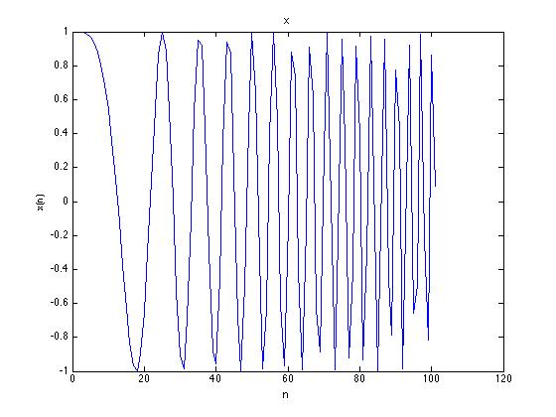

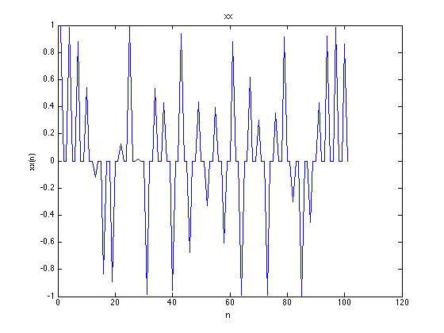

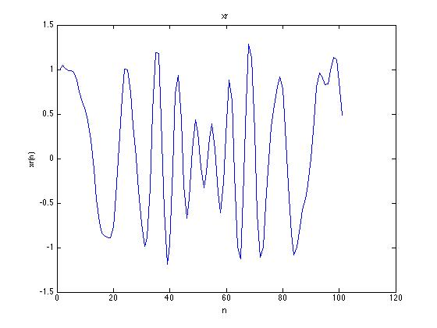

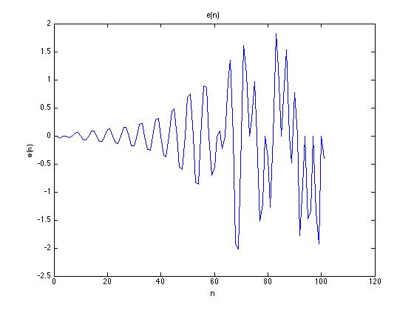

TAKE HOME MESSAGE: WE USE BANDLIMITED INTERPOLATION TO RECONSTRUCT THE MISSING OR ZERO SAMPLES OF INPUT SIGNAL.